Power BI Assessment Documentation

1. Overview
This Power BI dashboard visualizes real-time COVID-19 data using an online API source. It provides insights into total confirmed cases, deaths, recoveries, and region-wise comparisons. The goal of this project is to demonstrate the ability to integrate live API data, perform data transformation, apply error handling, and design an interactive analytical dashboard.

2. API Details
• API Used: https://disease.sh/v3/covid-19/countries
• Type: REST API (JSON format)
• Integration: Connected via Power BI → Get Data → Web → URL
• Refresh: Configured for automatic refresh to fetch updated COVID-19 data.

3. Data Flow & Error Handling
The data is fetched dynamically through the API and transformed in Power Query. The data flow involves connecting to the REST API endpoint, expanding JSON data, cleaning columns, and converting data types for visualization. To ensure data quality, an error handling logic is applied to detect and display issues if the API fails or returns empty data.
Error Handling Logic (Power Query M Code):
- if Table.IsEmpty(Source) then error "Data load failed: API returned no data" else Source

4. Dashboard Features
• KPIs: Total Confirmed Cases, Total Deaths, Total Recovered, Death Rate (%), Recovery Rate (%).
• Visuals: Map visualization for country distribution, bar chart for top 5 countries, line chart for WHO region trends.
• Filters: WHO Region and Country/Region slicers for interactivity.
• DAX Measures: Implemented for dynamic KPI calculations.
• Refresh: Configured to automatically pull new data from API.

5. DAX Measures Implemented
- Total Confirmed = SUM(countries[cases])
- Total Deaths = SUM(countries[deaths])
- Total Recovered = SUM(countries[recovered])
- Death Rate (%) = DIVIDE(SUM(countries[deaths]), SUM(countries[cases]), 0) * 100
- Recovery Rate (%) = DIVIDE(SUM(countries[recovered]), SUM(countries[cases]), 0) * 100
- Active Cases = SUM(countries[active])
- Cases per Million = DIVIDE(SUM(countries[cases]), SUM(countries[population]) / 1000000, 0)
- Deaths per Million = DIVIDE(SUM(countries[deaths]), SUM(countries[population]) / 1000000, 0)
Average Deaths per Country = AVERAGE(countries[deaths])

6. Screenshots
Please insert the following screenshots:
• Power Query Editor view showing data loaded from API.

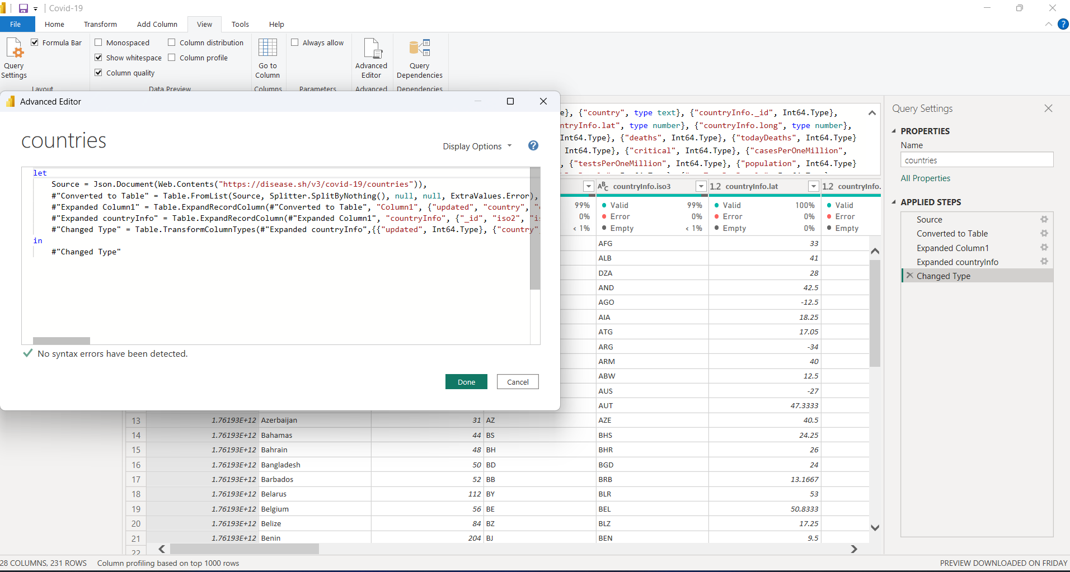
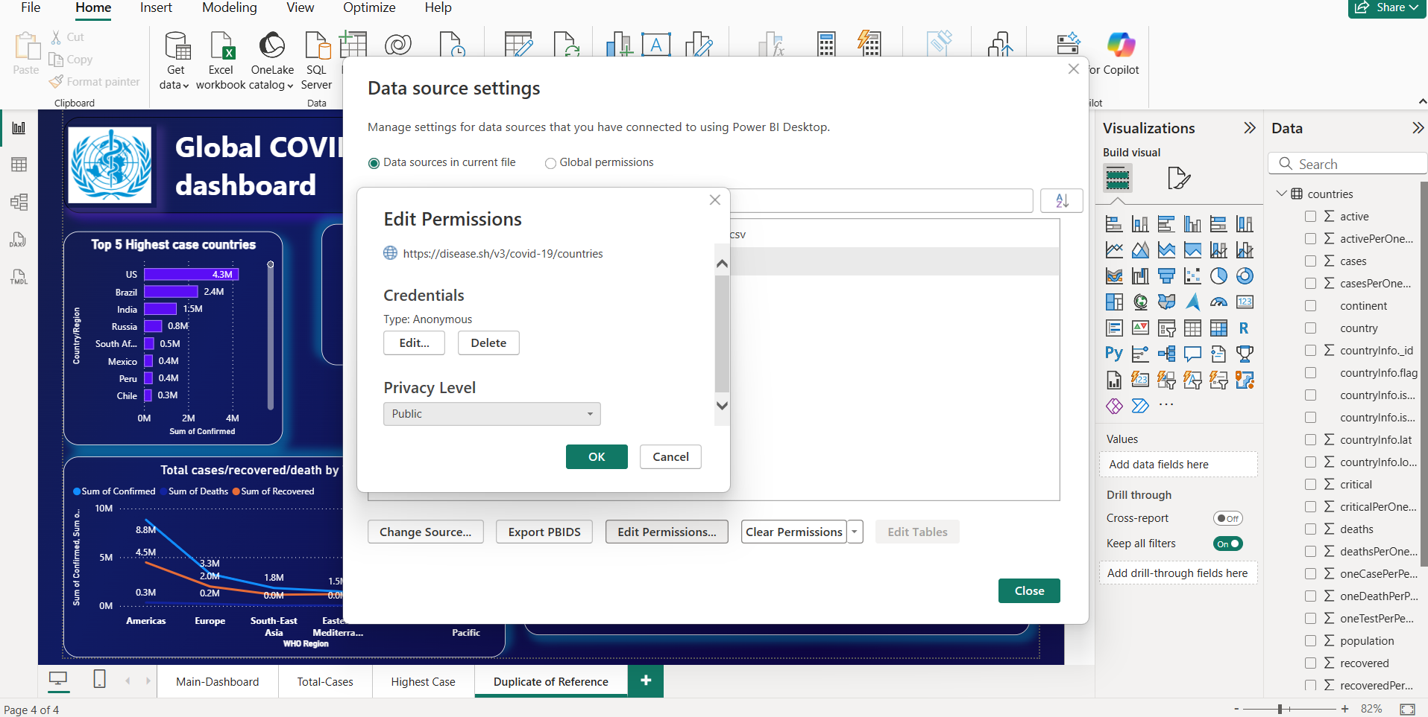

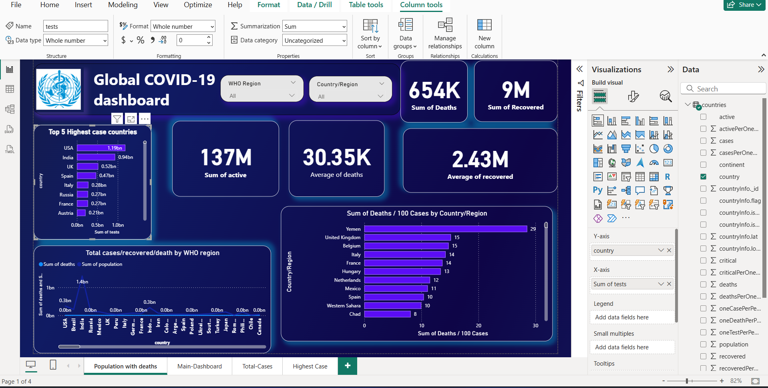

• Final Dashboard view displaying KPIs, charts, and map visualization.
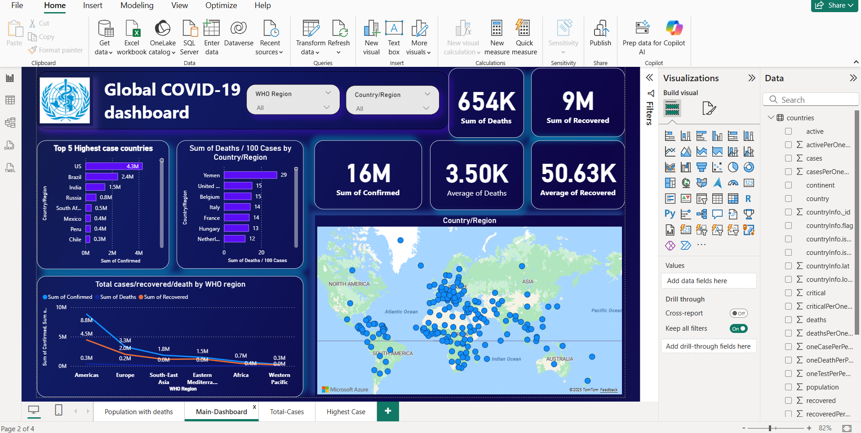

7. Conclusion
This project demonstrates the ability to design and develop a dynamic Power BI dashboard connected to a live API data source. It effectively visualizes key COVID-19 metrics with automated updates, error handling, and interactive insights.

